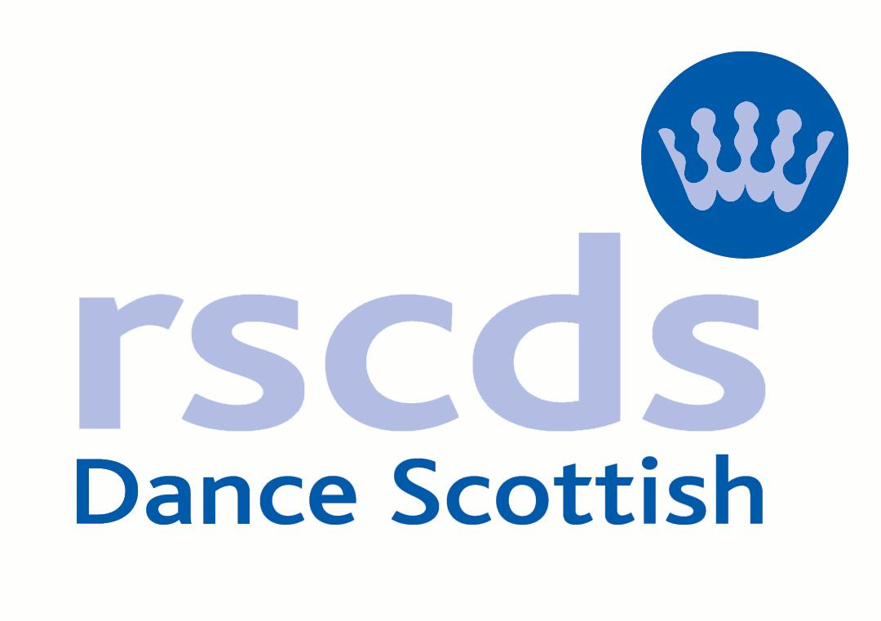 | Tunbridge Wells Branch

to be held on

Sunday 2nd July 2017

At
The Masonic Hall, London Road T.Wells TN4 9UY
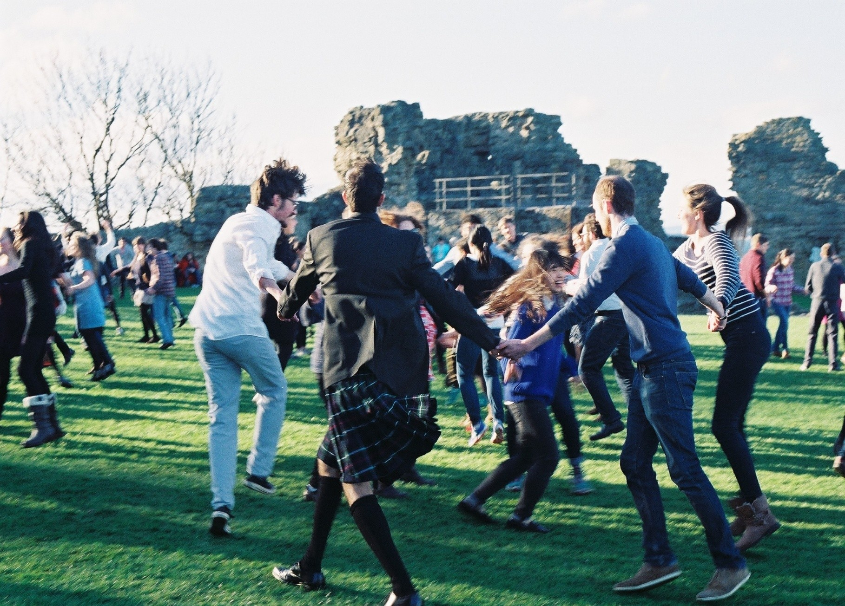
2.30 – 5.30pm
Tea, coffee, cake/biscuits provided at half time
There is no charge, but donations to cover hall hire and refreshments would be appreciated.
The RSCDS generally publishes a book of new dances each year and invites branches to evaluate dances which have been submitted. We have been asked to trial 8 new dances which have been put forward for inclusion into Book 52.

After you have danced each dance you will be asked to complete your assessment sheet, which will be collected up at the end of the day and sent to headquarters to allow them to decide which ones make it into the book. We need dancers of mixed experience in order to really put these dances through their paces.

Colin Simpson will be guiding you through the dances .
Contact details : Tel: 01892 532712. email: colin.simpson52@yahoo.co.uk

Everyone is welcome, just come along and enjoy the dancing, the dances are new to everyone, we are all in the same boat! The event is free, all we ask is you come along, dance and give us your opinion.

This is not an exclusively branch event, so please spread the word.

